TCS3200 Color Sensor

Cost – Rs 400-450

**Features and Specifications**

* Input voltage: (2.7V to 5.5V)
* Interface: Digital TTL
* High-resolution conversion of light intensity to frequency
* Programmable color and full-scale output frequency
* No need of ADC(Can be directly connected to the digital pins of the microcontroller)
* Power down feature
* Working temperature: -40oC to 85oC
* Size: 28.4x28.4mm(1.12x1.12")

The TCS3200 is programmable color light-to-frequency converters that combine configurable silicon photodiodes and a current-to-frequency converter on a single monolithic CMOS(Complementary metal–oxide–semiconductor) integrated circuit. The output is a square wave (50% **duty cycle**) with frequency directly proportional to light intensity (irradiance).

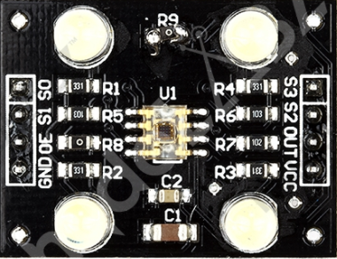

The sensor module consists of:

Header interface

4LEDs

A sensor cover

A sensor.

The sensor is made up of photodiodes and on the basis of the number of the module, it has either a 4x6 grid of diodes or a 8x8 grid.

The TCS3200 has an 8x8 grid of photodiodes. Sixteen photodiodes have blue filters, 16 photodiodes have green filters, 16 photodiodes have red filters, and 16 photodiodes are clear with no filters.

The pins on the module have the following meaning:

Vcc(5)- Supply Voltage.

GND(4)- Power supply ground.

S0(1)- Output frequency scaling selection input

S1(2)- Same as S0

S2(7)- Photodiode type selection input.

S3(8)-Same as S2

OE(3)- enable for f0 (active low).

OUT(6)- Output frequency.

|  |  |  |
| --- | --- | --- |
| S0 | S1 | Output Frequency Scaling |
| L | L | Power Down |
| L | H | 2% |
| H | L | 20% |
| H | H | 100% |

|  |  |  |
| --- | --- | --- |
| S2 | S3 | Photodiode type |
| L | L | Red |
| L | H | Blue |
| H | L | No filter |
| H | H | Green |

L – Low - 0

H – High - 1

HOW DOES IT WORK??

Light from the white LEDs is sent to the environment until it gets reflected back from a colored object. This reflected light is incident on the module.

When light is incident on the photodiode array, the diodes sense it and hence pass a current.

This current is then sent to a (Current-Frequency Converter) which then gives us a square wave with frequency directly proportional to light intensity.

The output which we get is usually a combination of RGB frequency data.

This data helps us to identify the colour of the objet from which light is reflected back.

CONNECTIONS:

Power-supply lines must be decoupled by a 0.01-μF to 0.1-μF capacitor with short leads mounted close to the device package.

A low-impedance electrical connection between the device OE pin and the device GND pin is required for improved noise immunity.

The output of the device is designed to drive a standard TTL or CMOS logic input over short distances. If lines greater than 12 inches are used on the output, a buffer or line driver is recommended.

Powering down the sensor using S0/S1 (L/L) will cause the output to be held in a high-impedance state. This is similar to the behavior of the output enable pin, however powering down the sensor saves significantly more power than disabling the sensor with the output enable pin

Output-frequency scaling is controlled by two logic inputs, S0 and S1.

------------------------------------------------------------------------------------------------------------------------------------------